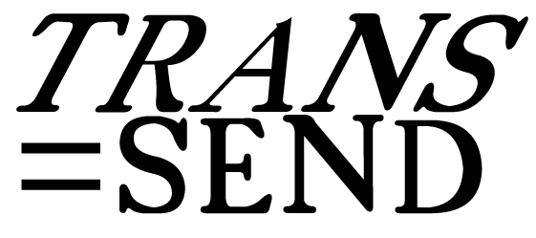 | 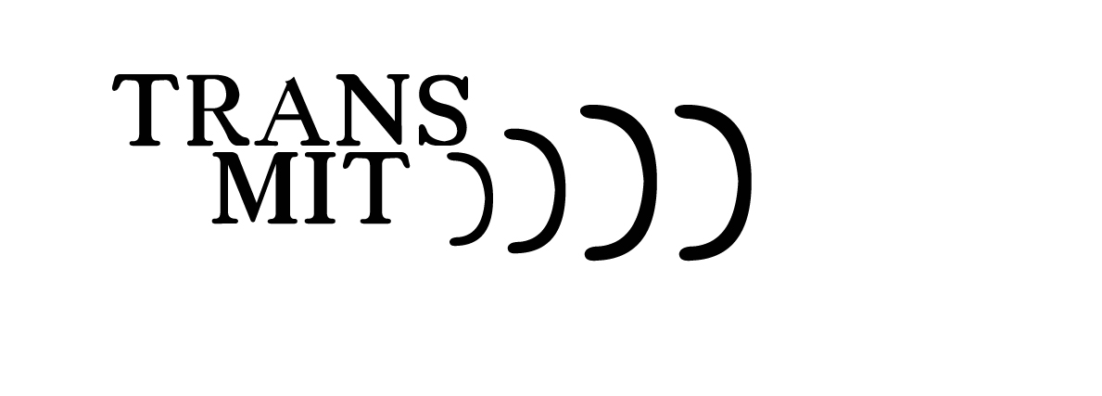

Holy Trinity, Sunderland (1719) and Holy Trinity, Leeds (1721) are two churches designed consecutively by William Etty (1675-1734, the York architect who was clerk of works at Castle Howard, not the painter) and are both being used increasingly for contemporary art installations and projects. There are many architectural resemblances and it is conjectured that the Sunderland church was an architectural rehearsal for the grander Leeds church. Trans=Send // Transmit seeks to connect artists living in the two areas through this connection.

Trans=Send is a Mail art project. A send and add to project, where artists in both locations would create an artwork that could be posted to the corresponding location. This artwork would then be displayed, chosen and worked upon by an artist in that location, and sent back, displayed and chosen, hopefully establishing some kind of visual / creative dialogue between artists in the two locations. The dialogue might be between just 2 artists or might evolve to include many.

Transmit is the radio element of the project. Ideally, artists will be invited to create pieces involving sound localised in the two churches and broadcast these between the two sites. Using the creative model of Mail art, that of communicating creative ideas through a system of send, response and relay, we hope to propagate a project where sound and radio artists will transmit ideas across this geographical area and collaborate on mini projects within the umbrella of the title. Radio practitioners are encouraged to draw diagrams on envelopes for inclusion within the mail art project, as to ideas already brewing for development.

Mail Art is active now!!! Depending on your location please send or take in your work to either:

Trans=send  c/o The Reg Vardy Gallery  Ashburne House  Ryhope Road  Sunderland  SR2 7EF | OR | Trans=Send  arts@Trinity  Holy Trinity Church  Boar Lane  Leeds  LS1 6HW
Work should be of a reasonable size and weight, preferably on an envelope / card / packet up to A5 in size. Please include your name (and address) clearly on the back so we can document this project properly!

Please remember your work WILL be worked upon by another artist, this being the nature of mail art! We will log and record who takes what when and when it is returned. I will be soon circulating flyers around various institutions in the North East and Leeds areas.

Further Information from louise@louisiem.com or come to our Lunch Bites session at Culture Lab, Newcastle University, July 2nd 12-1pm

